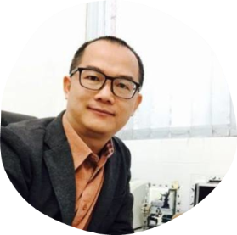

**Prof. Lu Yongjun**

Instructor

Why can such a respectable professor be so nice?!!!!

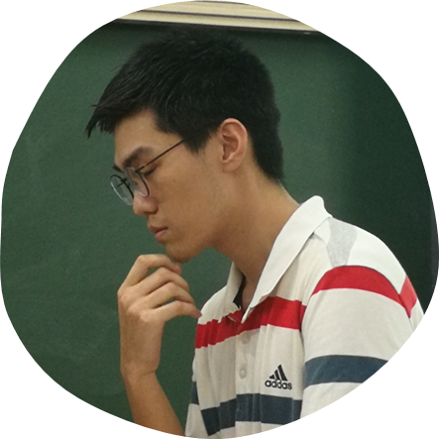

**Chen Jionglin**

Team leader, experiment, modelling, art design, etc.

Since I participated in iGEM, I’ve learned EVERYTHING.

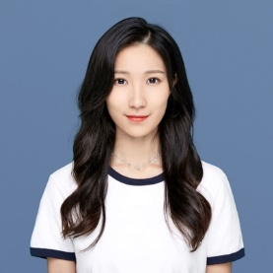

**Chang Yanqi**

Team leader, modelling, human practice

A consultant who doesn’t know biological data analysis is not a good team leader.

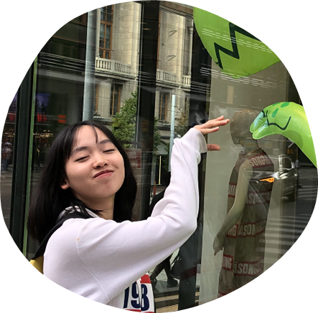

**Wu Zhien**

Molecular experiment, human practice

The world is worth the future.

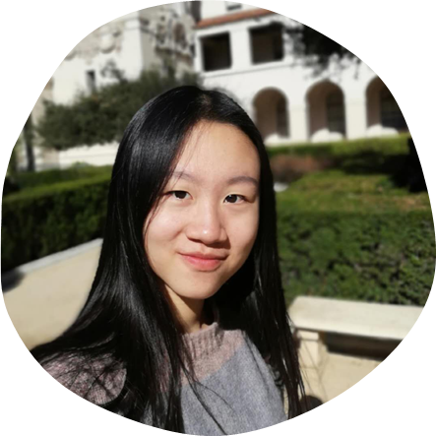

**Gao Shangfang**

Molecular and cell experiment

Shh!!! Don’t you see my 96-well plate?

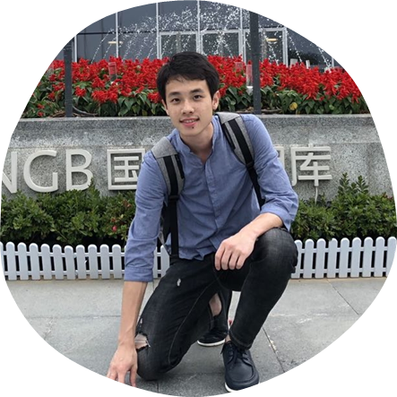

**Huang Junyu**

Human Practice

Connect with our treasure HP boy!

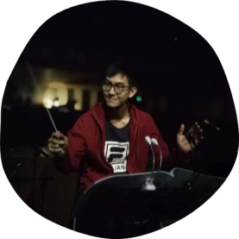

**Huang Ao**

Human Practice

It's fantasitic to see that you can make a difference to the world!

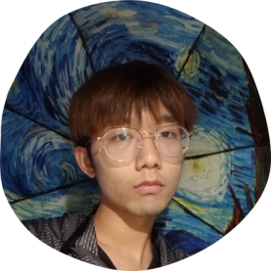

**Zhou Shuaixi**

Molecular experiment

Stay Cool.

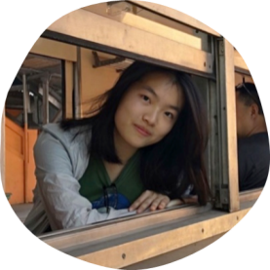

**Wen Rou**

Human Practice, experiment

Want to steal her GPA.

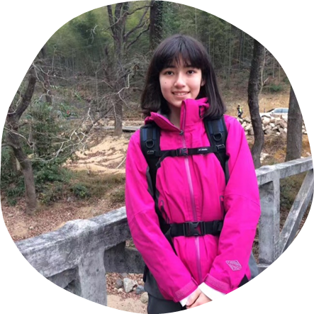

**Liu Lanjun**

Art design, experiment

Her paintings are as gorgeous as herself!

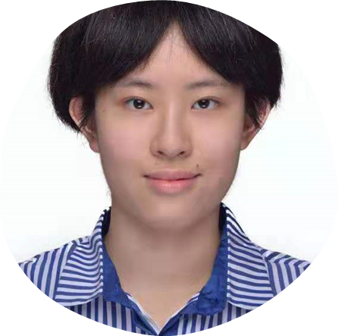

**Lu Yalin**

Art design

Draw it to fantasy.

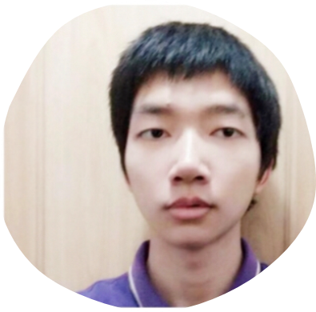

**Wang Chengwei**

Wiki builder, modelling

E5‌BD‌93 E4‌BD‌A0 E5‌87‌9D E8‌A7‌86 69 47 45 4D E6‌97‌B6 EF‌BC‌8C 69 47 45 4D E4‌B9‌9F E5‌9C‌A8 E5‌87‌9D E8‌A7‌86 E7‌9D‌80 E4‌BD‌A0 E3‌80‌82

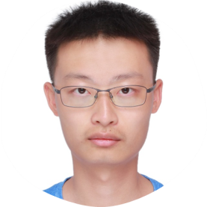

**Liang Jiaqi**

Modelling

Data in my hand, world in my mind.

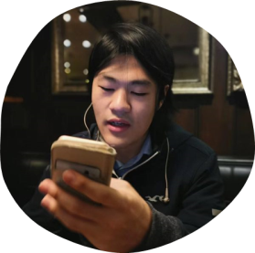

**Xu Jiaxian**

Advice provider, experiment

My wife: Hatsune Miku.

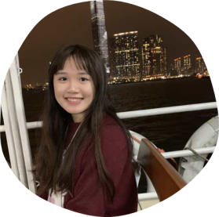

**WONG, Yuen Ying**

Experiment

The only medico in our team. Future Dr. Wong!

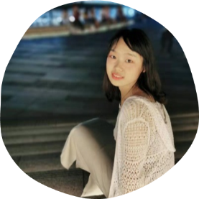

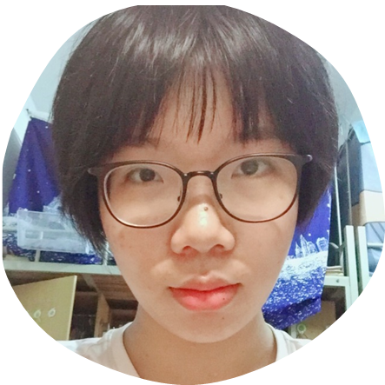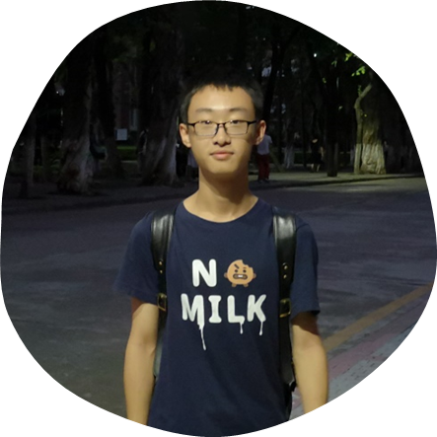

**He Yuansi, Wang Jiaxin, Zhao Bingnan**

Experiment helpers, art design assistants

Grow better together! Look forward to their show time in next year’s iGEM.